Cellular Transport Tutorial Name_________________________________________

Directions Access the interactive animations for cellular transport tutorial using the URL provided below or by clicking the link in Google Classroom. Use this tutorial to learn about the different types of cellular transport.
Interactive Concepts in Biochemistry: Cellular Transport
http://www.wiley.com/college/boyer/0470003790/animations/membrane_transport/membrane_transport.htm

First, use the internet or textbook to define “homeostasis” in living things. In the space provided below, write a brief explanation of homeostasis (What is it? Why is it important to living organisms?).

Second, what does it mean that a cell membrane is selectively permeable?

- What is cellular transport?

- Cellular transport allows cells to ________________________________ and ___________________________ compounds in accordance with its biological function.

- What two general characteristics of a molecule can prevent it from passing through the membrane?

- ____________________________ molecules will not pass due to their size.

- ____________________________ molecules will not pass both because they are highly attracted to extracellular (polar) water molecules and cannot easily pass through the non-polar membrane.

- Due to random ________________________ occurring in the cell’s membrane, small polar molecules such as water can pass through the membrane. Large polar molecules (such as sugar) can also pass through, but much less easily.
Diffusion/Osmosis
- After viewing the diffusion animation, write a brief explanation of diffusion (What is it? Why would this be important to living organisms?)

- During diffusion, molecules want to move from an area of _________________________ concentration to an area of ___________________ concentration.

- Draw an arrow to show where molecules are moving during diffusion in the picture below.

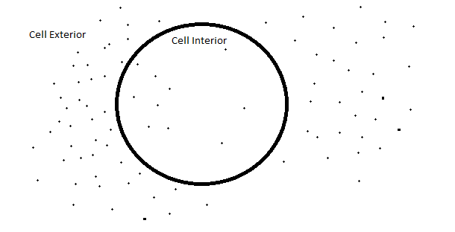

- At the start of the balloon animation, which side has a higher WATER concentration (compared to sugar)?

- During osmosis, _______________ molecules flow through the sugar-impermeable membrane. Impermeable means that sugar can’t move through (but remember that water can).

- After viewing the diffusion osmosis animation, write a brief explanation of osmosis (What is it? What is the purpose or “aim” of osmosis? Why would this be important to living organisms?)

- What would eventually happen to a cell placed in distilled water? Why?

- What would happen in the above diagram (see #9), if the molecules could NOT move through the membrane? In other words, which way would the water flow (into or out of) to create an equal concentration of sugar on both sides of the membrane?

Passive Transport
- What do you call the specialized proteins aid (facilitate) the passage of molecules across membranes?

- List and briefly describe the three steps necessary for the passage of a molecule into a cell through passive transport.

- True or False Passive transporters require energy in the form of ATP to move molecules?

- True or False Active transporters require energy in the form of ATP to move molecules?

- Passive transporters move molecules from _________________ concentration regions to __________________ concentration regions.

Active Transport

- Active transporters can move molecules from areas of __________________ concentration to areas of _________________ concentration (against equilibrium).

- _______________ in the required form of energy that is required for active transport.

- Our ___________________ cells rely on active transport to maintain the correct electrical potential across the membrane. ATPase pumps move sodium (Na⁺) and potassium (K⁺) ions across the cell membrane.

