Graphing Practice #1 Name

Directions-Use graph paper to construct a complete line graph for each set of data!

Example 1: | The table below shows daily temperatures for New York City, recorded for 6 days, in degrees Fahrenheit.
Temperatures In NY City
Day | Temperature
1 | 43° F
2 | 53° F
3 | 50° F
4 | 57° F
5 | 59° F
6 | 67° F

Example 2: | Sarah bought a new car in 2001 for $24,000. The dollar value of her car changed each year as shown in the table below.
Value of Sarah's Car
Year | Value
2001 | $24,000
2002 | $22,500
2003 | $19,700
2004 | $17,500
2005 | $14,500
2006 | $10,000
2007 | $ 5,800

Example 3: | The table below shows Sam's weight in kilograms for 5 months.
Sam's Weight
Month | Weight in kg
January | 49
February | 54
March | 61
April | 69
May | 73

Graphing Practice #2 Name

Example #1 Questions
1. | What is the title of this line graph?
2. | What is the range of values on the horizontal scale?
3. | What is the range of values on the vertical scale?
4. | How many points are in the graph?
5. | What was the lowest temperature recorded?
6. | What was the highest temperature recorded?
7. | At what point did the temperature dip?

Example #2 Questions
1. | What is the title of this line graph?
2. | What is the range of values on the horizontal scale?
3. | What is the range of values on the vertical scale?
4. | How many points are in the graph?
5. | What was the highest value recorded?
6. | What was the lowest value recorded?
7. | Did the value of the car increase or decrease over time?

Example #3 Questions
1. | What is the title of this line graph?
2. | What is the range of values on the horizontal scale?
3. | What is the range of values on the vertical scale?
4. | How many points are in the graph?
5. | What was the highest value recorded?
6. | What was the lowest value recorded?
7. | Did Sam's weight increase or decrease over time?

Graphing Practice #3 Name

Example 4: | The line graph below shows people in a store at various times of the day.
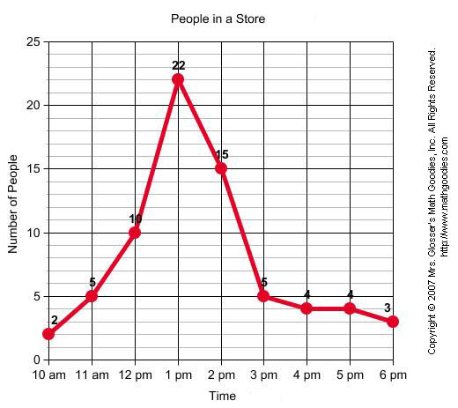
QUESTION
1. | What is the line graph about?
2. | What is the busiest time of day at the store?
3. | At what time does business start to slow down?
4. | How many people are in the store when it opens?
5. | About how many people are in the store at 2:30 pm?
6. | What was the greatest number of people in the store?
7. | What was the least number of people in the store?

Example 5: | The line graph below shows the number of teens ages 13 through 19 in Smalltown that have cell phones.

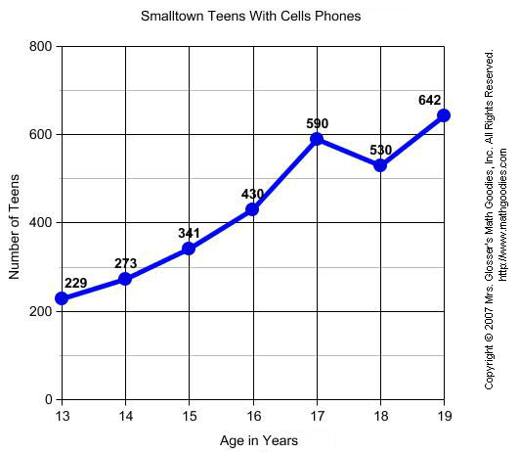
QUESTION
1. | What is the line graph about?
2. | At what age do teens have the greatest number cell phones?
3. | At what age do teens have the least number of cell phones?
4. | How many cell phones do 15 year-olds have?
5. | About how many cell phones do 16.5 year-olds have?
6. | What was the greatest number of cell phones at any age?
7. | What was the least number of cell phones at any age?

Graphing Data Practice Name

The following data was collected as a bicyclist was traveling around a track. Use graph paper and construct a graph of the data.

Time (s) | Distance (m)
0 | 0
1 | 2
2 | 8
3 | 18
4 | 32
5 | 50
6 | 72
7 | 98
8 | 128
9 | 162
10 | 200

Questions-
- What is the shape of your graph?

- What type of relationship is this?

- What type of motion is this?

- How far did the bicyclist travel at t = 9.5 s?

- Assume the bicyclists maintains a constant speed…what distance will be covered in t = 15 s?

- Calculate the slope of this line!

- What does the slope of this graph tell us?

